* **Comparable Interface**:

The `Comparable` interface is used to define the **natural ordering** of objects. It allows an object to compare itself with another object of the same type. The interface has one method:

public int compareTo(T o);

Return Value:

Negative: If the current object is less than the other object.

Zero: If the current object is equal to the other object.

Positive: If the current object is greater than the other object.

Code Explanation

In your code, the `Student` class implements `Comparable<Student>`:

java

class Student implements Comparable<Student> {

int rollno;

String name;

Student(int rollno, String name) {

this.rollno = rollno;

this.name = name;

}

@Override

public int compareTo(Student other) {

return this.rollno - other.rollno; // Natural ordering based on rollno

}

@Override

public String toString() {

return "[" + rollno + ", " + name + "]";

}

}

**Natural Ordering**: The `compareTo` method defines the natural ordering of `Student` objects based on their `rollno`. This means that when you sort a list of `Student` objects, they will be ordered by their `rollno`.

Usage Example

import java.util.*;

public class Main {

public static void main(String[] args) {

List<Student> students = new ArrayList<>();

students.add(new Student(3, "Charlie"));

students.add(new Student(1, "Alice"));

students.add(new Student(2, "Bob"));

// Sorting using natural ordering (defined by compareTo)

Collections.sort(students);

System.out.println(students); // Output: [[1, Alice], [2, Bob], [3, Charlie]]

}

}

Key Points:

- The `Collections.sort()` method uses the `compareTo` method defined in the `Comparable` interface to sort the list.

- The `toString()` method is overridden to provide a readable representation of the `Student` objects.

* **Comparator Interface**

The `Comparator` interface is used to define **custom ordering** for objects. Unlike `Comparable`, which defines the natural ordering, `Comparator` allows you to define multiple sorting criteria for the same class.

The interface has one key method:

public int compare(T o1, T o2);

Return Value:

- Negative: If `o1` is less than `o2`.

- Zero: If `o1` is equal to `o2`.

- Positive: If `o1` is greater than `o2`.

Why Use Comparator?*

- When you want to sort objects in a way that differs from their natural ordering.

- When you cannot modify the original class (e.g., if it's part of a library).

Example Using Comparator

You can create a `Comparator` to sort `Student` objects by `name` instead of `rollno`:

import java.util.*;

public class Main {

public static void main(String[] args) {

List<Student> students = new ArrayList<>();

students.add(new Student(3, "Charlie"));

students.add(new Student(1, "Alice"));

students.add(new Student(2, "Bob"));

// Sorting using a custom Comparator (by name)

Comparator<Student> nameComparator = new Comparator<Student>() {

@Override

public int compare(Student s1, Student s2) {

return s1.name.compareTo(s2.name); // Compare names lexicographically

}

};

Collections.sort(students, nameComparator);

System.out.println(students); // Output: [[1, Alice], [2, Bob], [3, Charlie]]

}

}

Differences Between `Comparable` and `Comparator`

| Feature | `Comparable` | `Comparator` |

|--------------------------|-------------------------------------------|-------------------------------------------|

| **Purpose** | Defines the natural ordering of a class. | Defines custom ordering for a class. |

| **Method** | `compareTo(T o)` | `compare(T o1, T o2)` |

| **Location** | Implemented in the class itself. | Implemented externally (as a separate class or lambda). |

| **Flexibility** | Limited to one natural ordering. | Allows multiple sorting criteria. |

| **Use Case** | When the class controls its own ordering.| When you need additional sorting logic. |

Ways to Use `Comparator`

#### **a. Anonymous Class**

You can define a `Comparator` using an anonymous class:

Comparator<Student> nameComparator = new Comparator<Student>() {

@Override

public int compare(Student s1, Student s2) {

return s1.name.compareTo(s2.name);

}

};

Lambda Expression (Java 8+)

Lambda expressions simplify the creation of `Comparator` instances:

Comparator<Student> nameComparator = (s1, s2) -> s1.name.compareTo(s2.name);

Method References

If the comparison logic is already defined in a method, you can use a method reference:

Comparator<Student> nameComparator = Comparator.comparing(s -> s.name);

Or even shorter:

Comparator<Student> nameComparator = Comparator.comparing(Student::getName);

Chained Comparators

You can chain multiple comparators to define complex sorting logic:

Comparator<Student> rollnoThenNameComparator = Comparator

.comparingInt(Student::getRollno)

.thenComparing(Student::getName);

Important Things to Know

a. Stability of Sorting

- Sorting algorithms like `Collections.sort()` are **stable**, meaning that equal elements retain their relative order.

b. Null Handling

- Both `Comparable` and `Comparator` can throw `NullPointerException` if `null` values are compared.

- To handle `null` values, you can use `Comparator.nullsFirst()` or `Comparator.nullsLast()`:

Comparator<Student> nullSafeComparator = Comparator.comparing(Student::getName, Comparator.nullsFirst(Comparator.naturalOrder()));

c. Reverse Order

- You can reverse the order of a `Comparator` using `reversed()`:

Comparator<Student> reverseNameComparator = Comparator.comparing(Student::getName).reversed();

d. Primitive-Specific Comparators

- For primitive types, use specialized comparators like `Comparator.comparingInt()`, `Comparator.comparingDouble()`, etc., for better performance.

Comparator<Student> rollnoComparator = Comparator.comparingInt(Student::getRollno)

Summary of Usage Patterns

| Pattern | Example |

|--------------------------|-------------------------------------------------------------------------|

| Comparable (Natural) | `Collections.sort(students);` |

| Comparator (Anonymous) | `Collections.sort(students, new Comparator<Student>() { ... });` |

| Comparator (Lambda) | `Collections.sort(students, (s1, s2) -> s1.name.compareTo(s2.name));` |

| Comparator (Method Ref) | `Collections.sort(students, Comparator.comparing(Student::getName));` |

| Chained Comparators | `Comparator.comparingInt(Student::getRollno).thenComparing(Student::getName);` |

| Null-Safe Comparator | `Comparator.comparing(Student::getName, Comparator.nullsFirst(...));` |

| Reverse Order | `Comparator.comparing(Student::getName).reversed();` |

Final Answer

- Comparable is used to define the **natural ordering** of objects within the class itself.

- Comparator is used to define **custom ordering** externally, allowing flexibility for multiple sorting criteria.

- Both can be implemented using traditional methods, anonymous classes, lambda expressions, or method references.

- Key features include handling `null` values, reversing order, chaining comparators, and optimizing for primitives.

By understanding and leveraging both `Comparable` and `Comparator`, you can write flexible and efficient sorting logic in Java.

**Exception Handling**

An exception is an unwanted or unexpected event, which occurs during the execution of a program i.e. at run time, that disrupts the normal flow of the program.

When such unexpected event and we solve it with alternate way and we called it as Exception handling

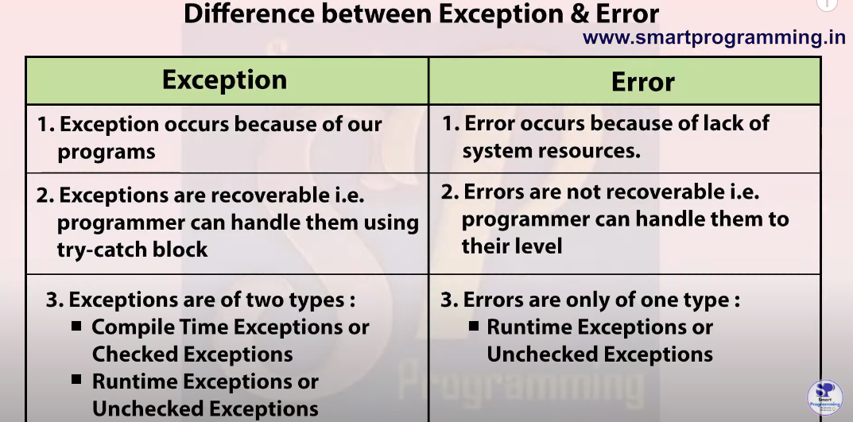

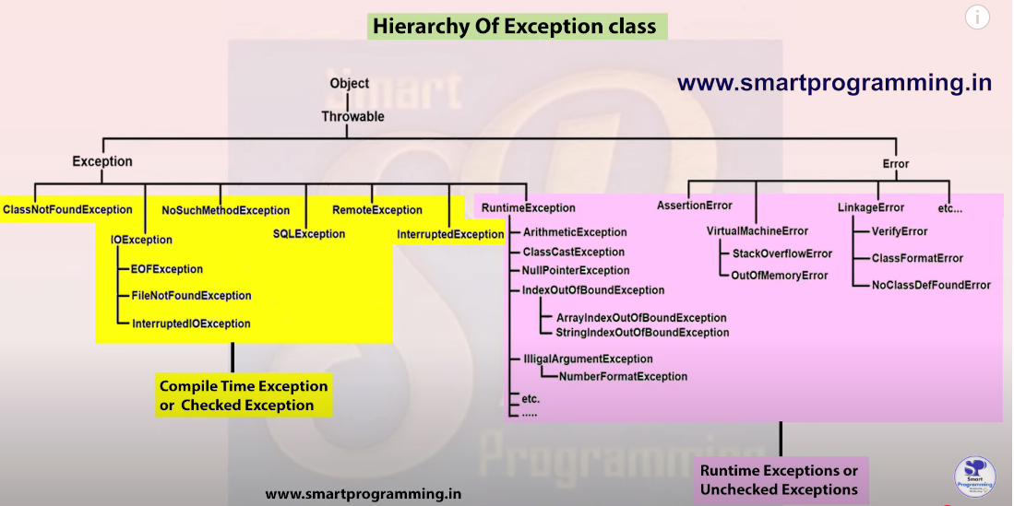

Exceptions always occur at runtime. **Exception does not occur at compile time.**

Compile time pe compiler warn karta hai ki future mai ye exception aa sakti hai isse handle karo (using try-catch) aur ye exception nhi hota. Jab ham warning ko handle kar lete hai tab code compile hoga but jo warning mili thi waise hi problem hai to runtime pe exceotion aaegi.

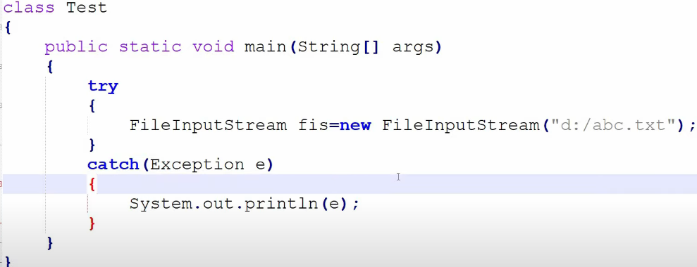

Abc.txt does not exists.

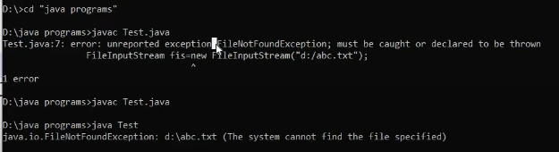

1st compiler bata raha hai warn kar rha hai

2nd exception occur hui

**Checked** Exception (**Compile** time exception)

Aisi exception jo compiler apne level pe check kar sakta hai aur bolta hai isse handle karo (try-cath, throw, throws).

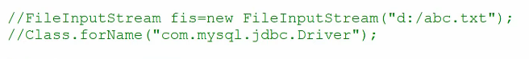

**Unchecked** Exception (**Runtime** exception)

In unchecked compiler is not able to check the exception. Compiler Ignore it.

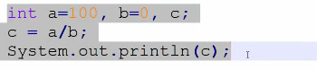

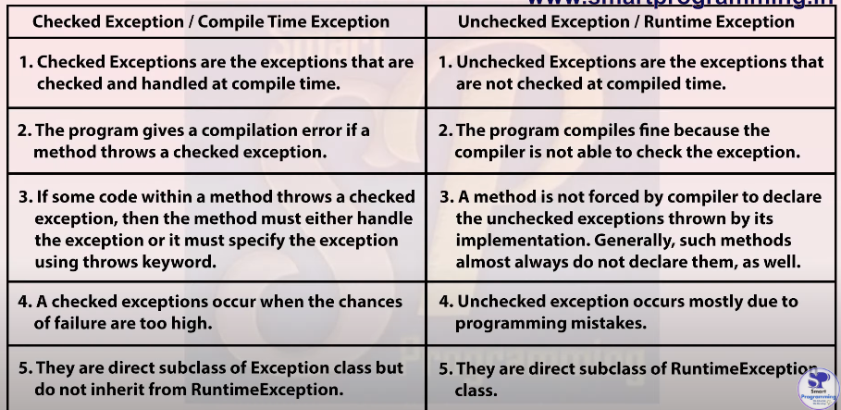

How to handle exception (Checked & Unchecked).

Whenever there is exception, the method in which exception occurs will create an object and that object will store three things.

1. Exception name
2. Description
3. Stack trace (Proper long description)

JVM Default Exception Handler (method) ye object pass kar dega agar use handle nhi kiya gya hai aur use pehle program abnormally terminate ho jaega.

We can handle the exception using 5 keywords

1. Try
2. Catch
3. Finally
4. Throw
5. Throws

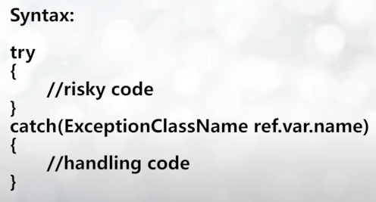

Flow of try-catch

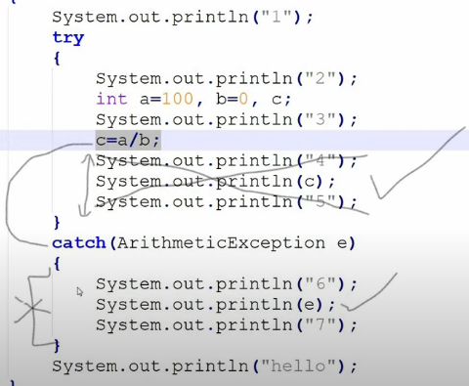

Printing Exception

1. E.printStackTrace() (Most Used)

Name, description, stack trace (line)

1. Sout(e)

Name, description

1. Sout(e.getMessage())

description

**Finally** Block:

Always executes whether exception occurred or not. It is used to write a **clean up code** like closing db connection, resources that we tried to open in try we will close that in finally block.

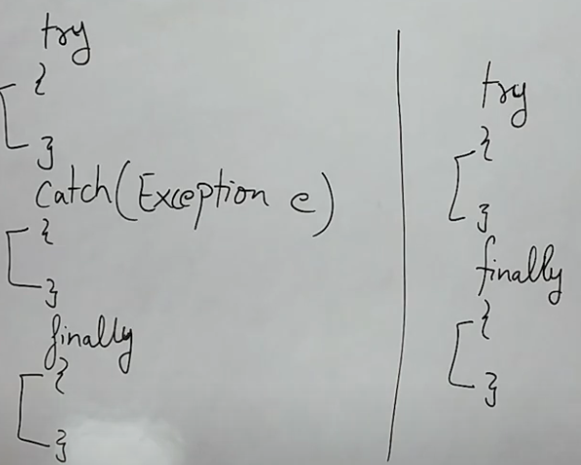

Try ke baad directly finally use kar sakte hai but exception handle nhi hoga. Preferred way to use is try-catch-finally

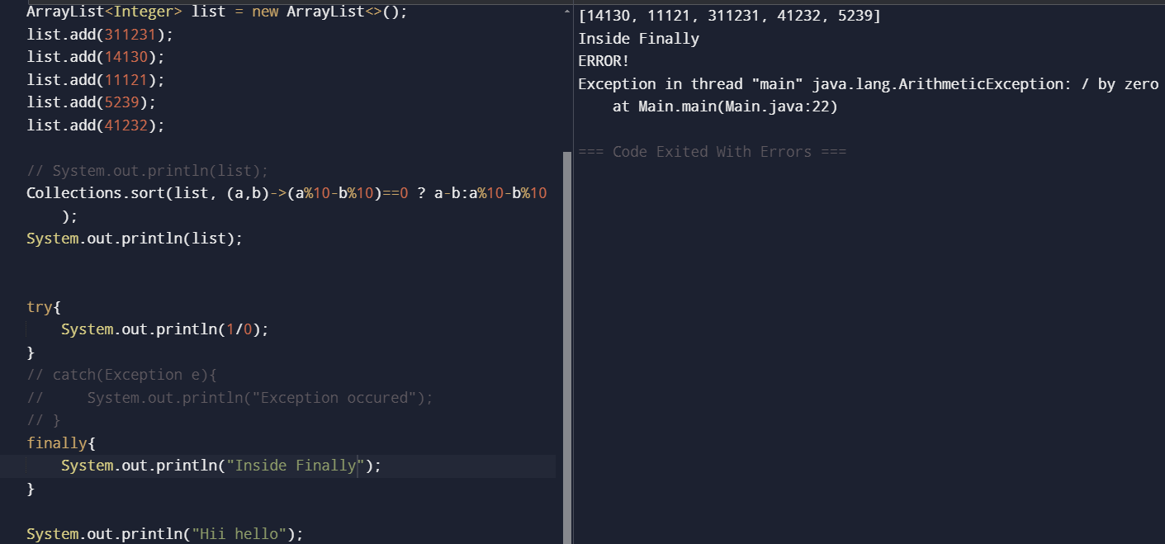

Akela try, catch or finally block nhi allowed hai compilation error

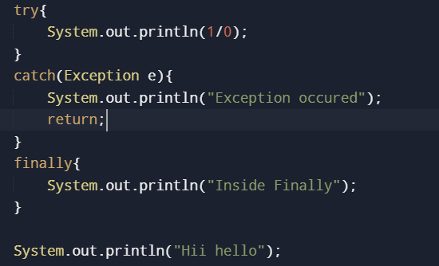

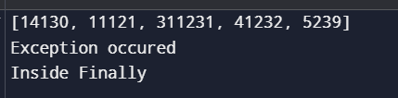

If return is in try or catch block than also finally will run but below finally codes will not run

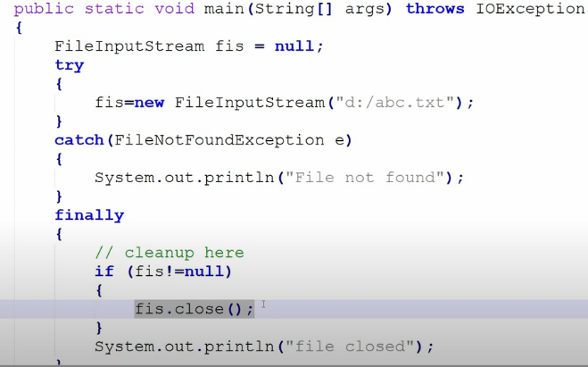

We can use multiple catch blocks with one try block but we can only use single finally block with one try block, not multiple.

**The statements** present in the finally block execute even if the try block contains control transfer statements (i.e. jump statements) like ***return, break or continue*.**

Four Scenarios where finally block does not execute

1. Using of System.exit(0) method inside try
2. Causing a fatal error that causes the process to abort (outofmememory etc.)
3. Due to exception arising in the finally block
4. The death of a Thread

Difference between **final, finally, finalize**

Finalize method is just executed prior to garbage collector. Clean is performed

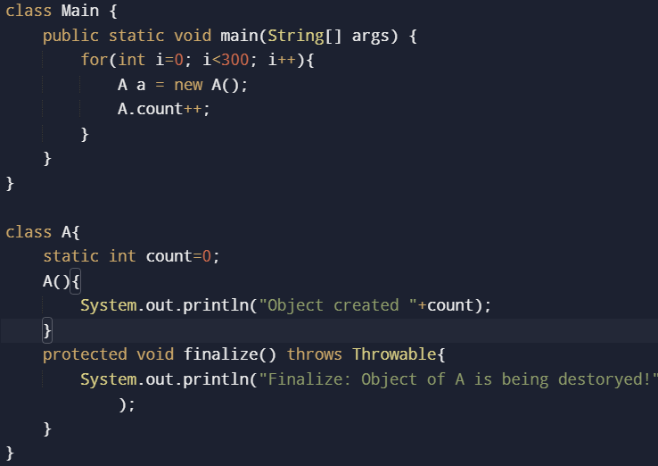

Possible combinations of try-catch-finally

1. Alone any cannot exist
2. Multiple catch block can be used with single try but Parent (Exception) should be last. If it is first than error. Two same classes in catch cannot be provided

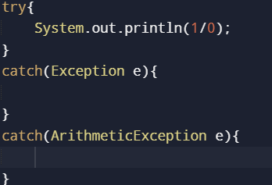

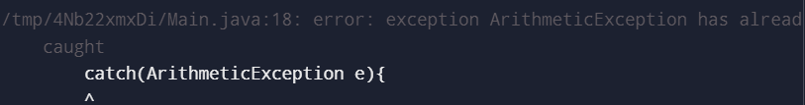

1. Nesting is allowed. Try-Catch can be written inside try, catch, and finally block

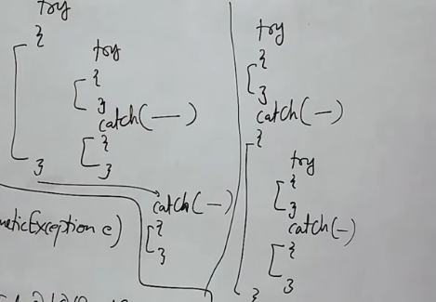

1. Try ke baad finally directly

**Throw**:

Throw keyword is used to throw user defined exceptions. If you use existing exception the program will run fine but that is not recommended. Customized exception ke liye throw keyword use hota hai.

Here a programmer manully creates a exception object using throw keyword. But exception handle karna padega using try-catch kyunki throw bhi abnormally program ko terminate kar dega

throw new UserException();

Check exception when extending to Exception class

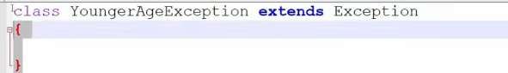

Uncheck

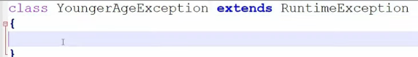

It is better to make customized exception unchecked

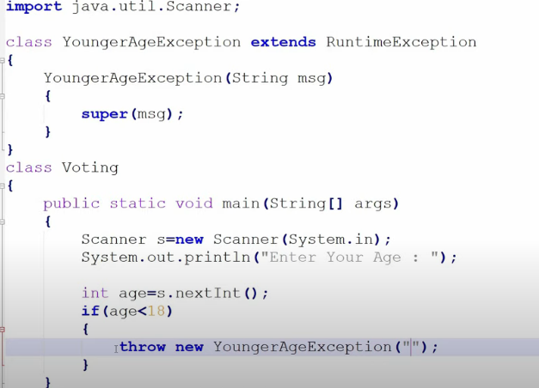

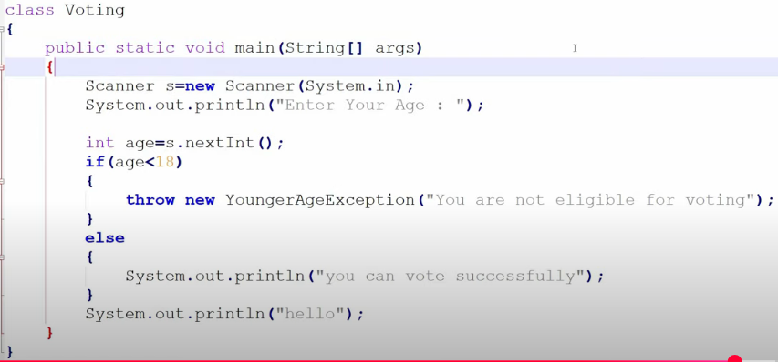

User made a custom exception and had use throw keyword to manually create a exception object. JVM ask main method did you handle this exception main said No than JVM gives the exception object to Default Exception handler DEH and it prints the exception object and program ko abnormally terminate kar dega.

Handling throw exception

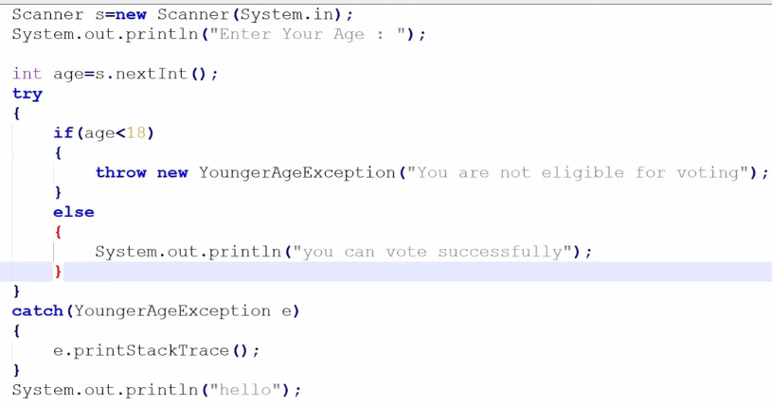

Summary

1. Throw is used to throw user defined exception that are mainly unchecked (RuntimeException)
2. It manually create an exception object and gives it to jvm
3. You cannot write any statement after throw will give compilation error

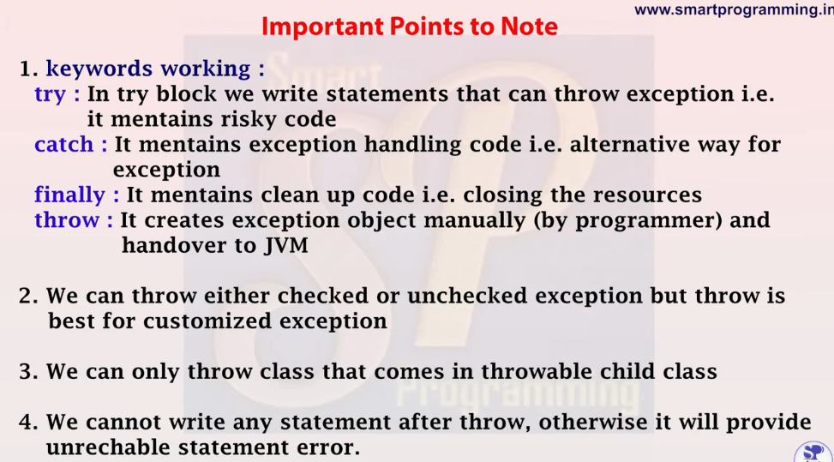

**Throws (**method ke sath use hot hai**)**

Throws keyword is used to declare an exception. It gives an information to the caller method that there may occur an exception so it is better for the caller method to provide the exception handling code so that normal flow can be maintained.

Ye maine ek method bana diya isse tum use karo but be cautious as this method can throw an exception so please handle it.



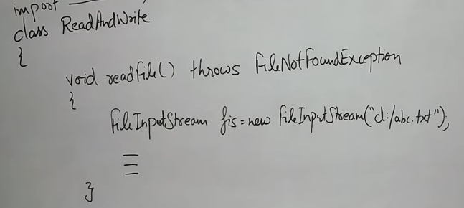



**Throws is used with checked exception**

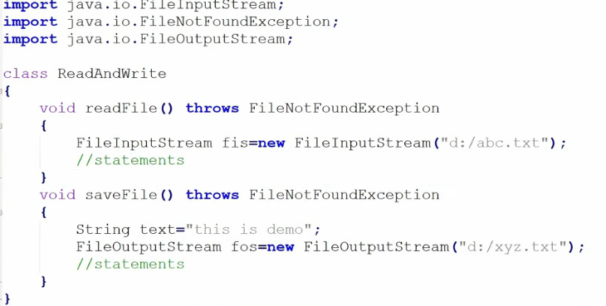

Handling exception

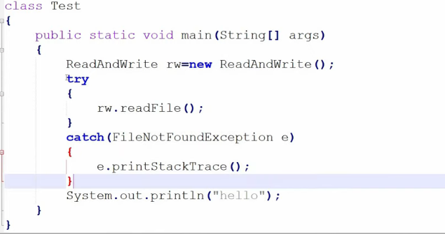

Compiled but will not handle exception and program will terminate abnormally.

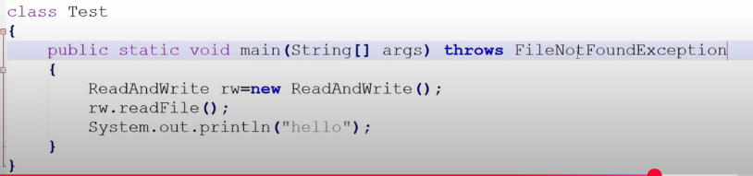



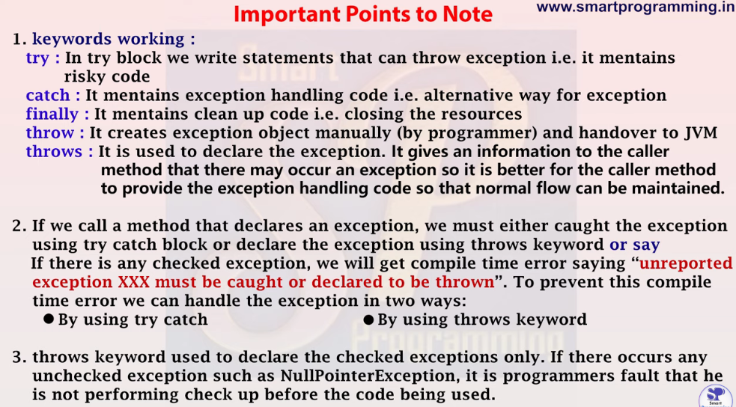

**Difference** between throw and throws

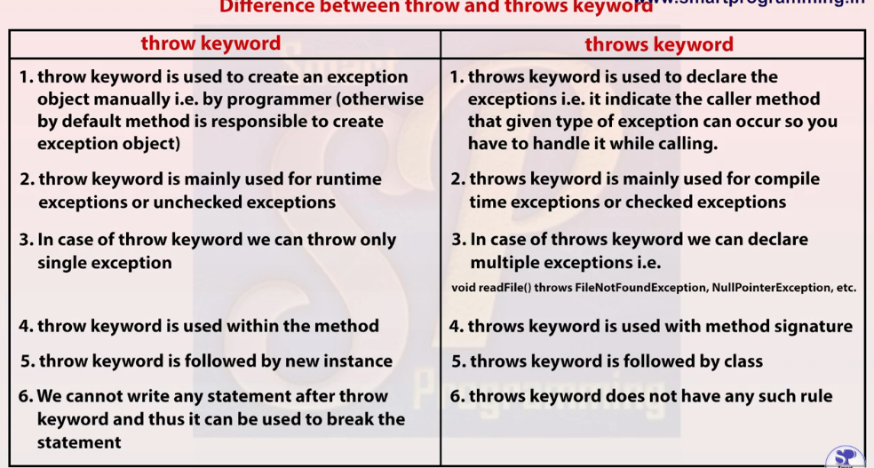

**Custom** Exception

Checked exception so extend Exception class

If throwing an checked exception so use try-catch or throws to compile the code.

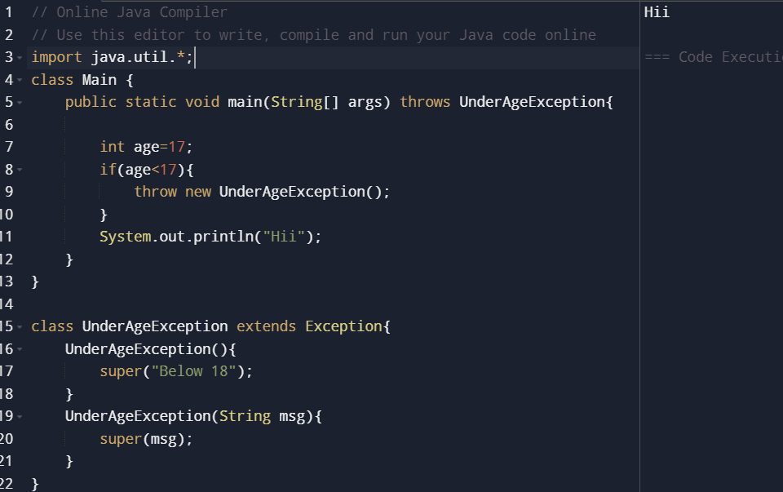

Unchecked exception so extend RuntimeException class

The code will **compile** successfully without try-catch or throws but during runtime it can give exception

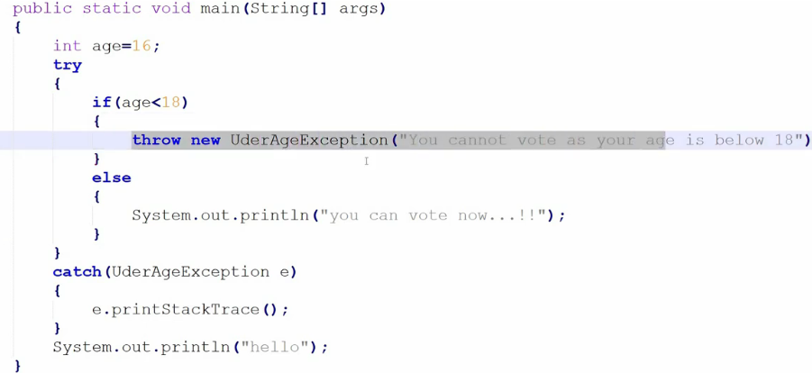

Throw can be used to throw system exception as well as customized exception. But best for throwing customized exception.

**Working of HashMap.**

<https://www.youtube.com/watch?v=sw-j_ETGBEo>

Put(null,null) get stored at 0th index.

In form of ll node key, values are stored if collision occurs than chaining

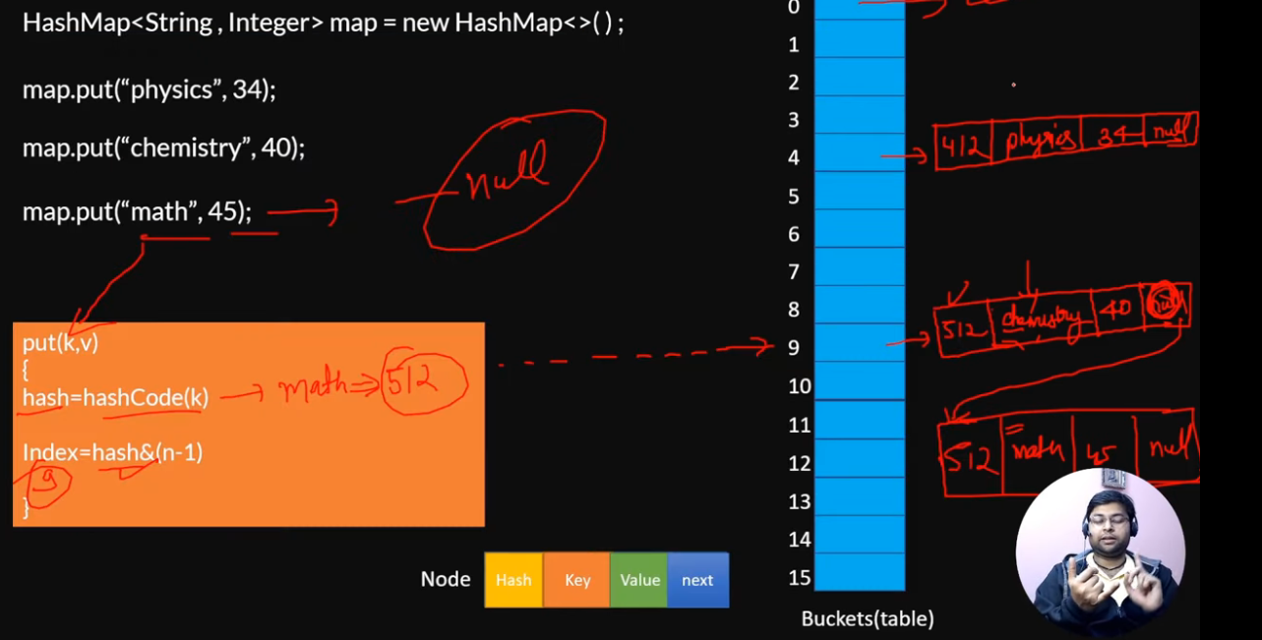

From java 8 onward if there is huge collision and size of a particular bucket increases the threshold than BST is used to reduced the TC of put and get from O(n) to O(logn)

Get Operation:

<https://www.youtube.com/watch?v=X2k-NTmswVs>

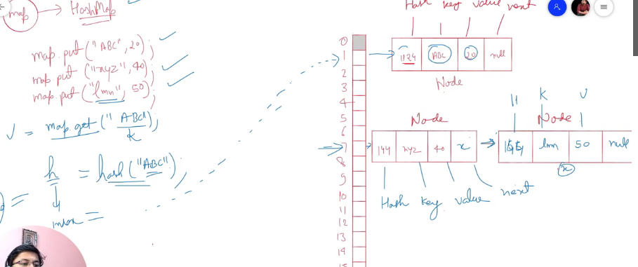

Top 15 Hashmap interview questions.

<https://www.youtube.com/watch?v=OGGHFabY9G4&list=PL0zysOflRCen9SPmMO2XN1I2S9m96G_dx&index=6&t=18s>

HashMap can have **one null key** and any number of null values.

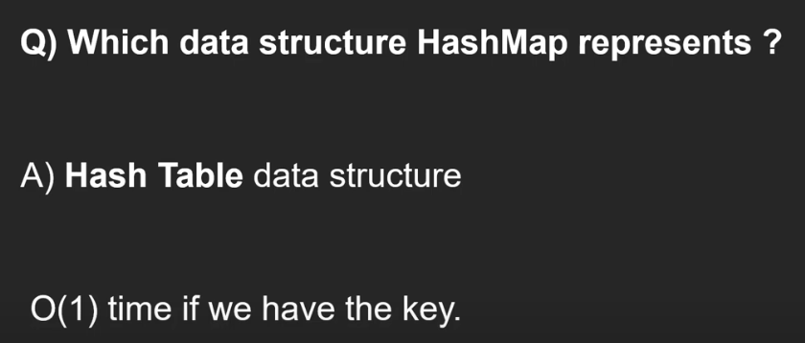

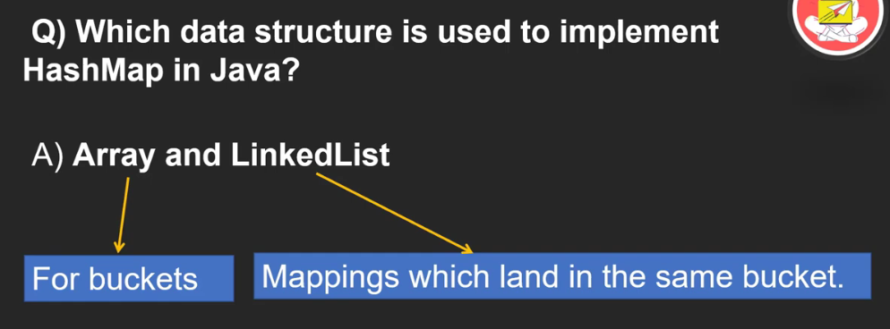

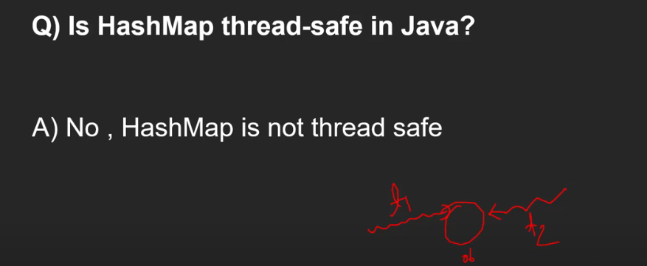

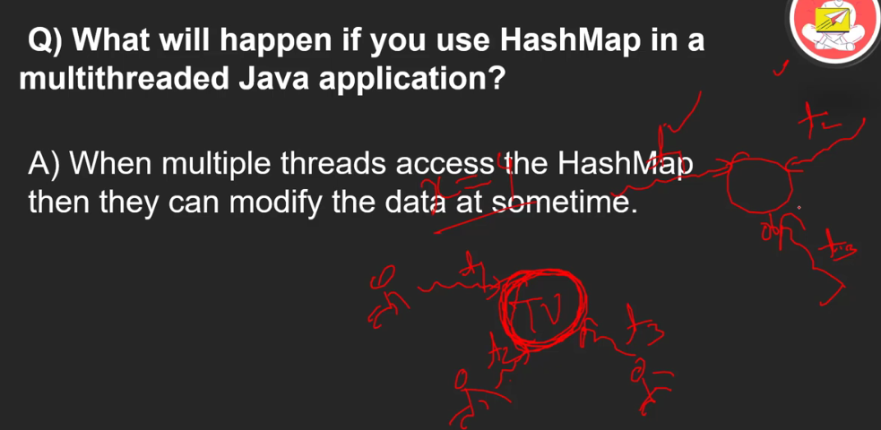

Use ConcurrentHashMap for thread safe

Trying to **remove** key from map while iterating not possible

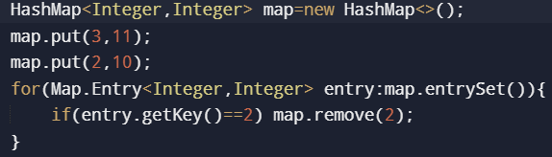

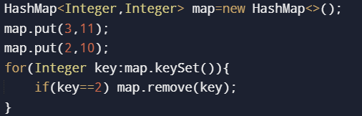

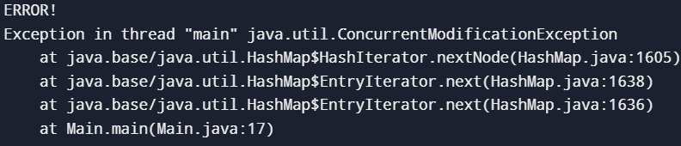

We can use iterator on keyset() and keyentry() to remove while iterating.

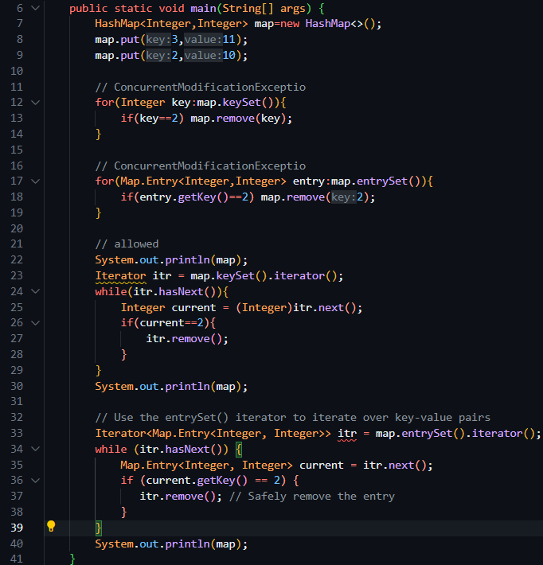

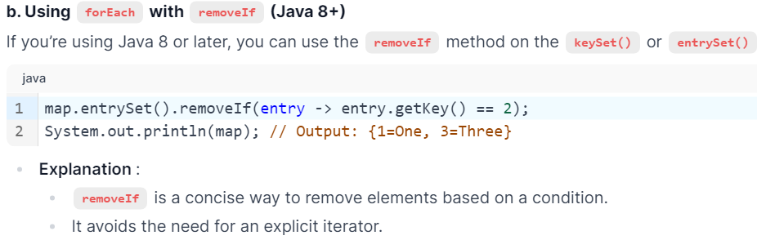

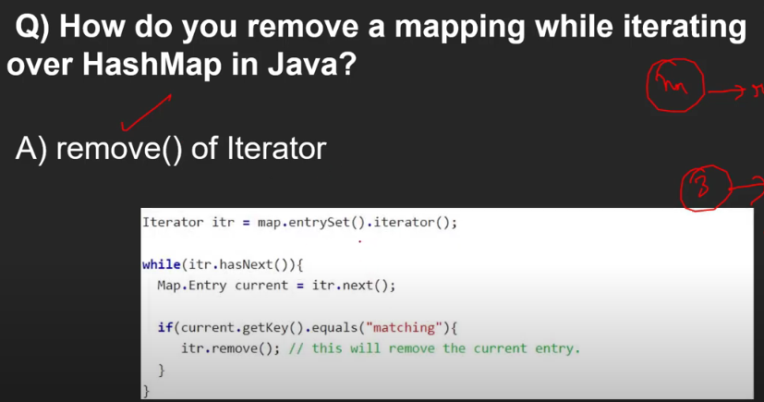

removeIf() can also be used.

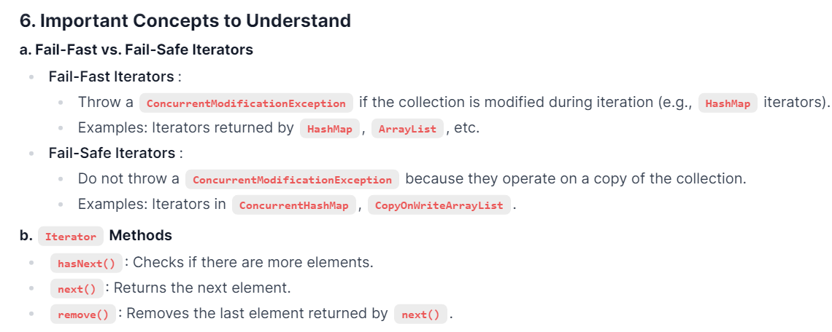

Set:

The same concept applies to **Set**. You cannot modify a **Set** directly while iterating over it using a **for-each** loop or other means. Instead, you must use the **Iterator's remove() method** or the **removeIf method** in Java 8+. Understanding these concepts is crucial for working with Java collections and answering related interview questions effectively.

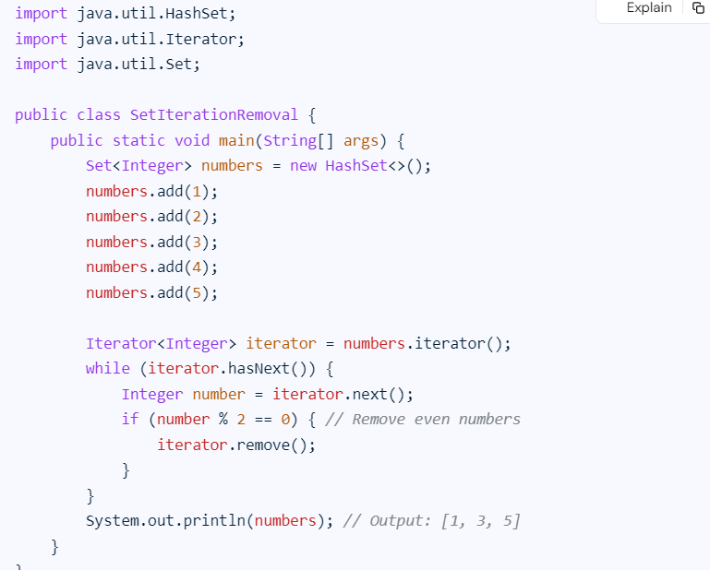

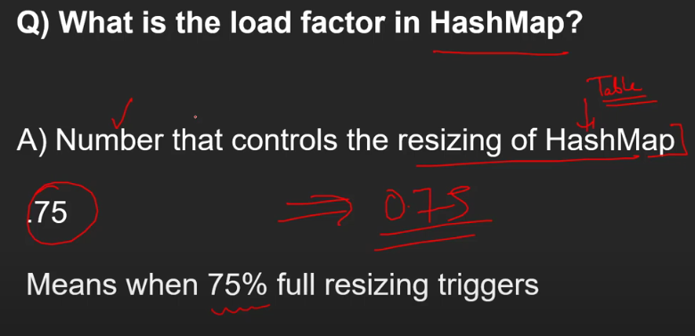

0.75f load factor

Intial capacity 16

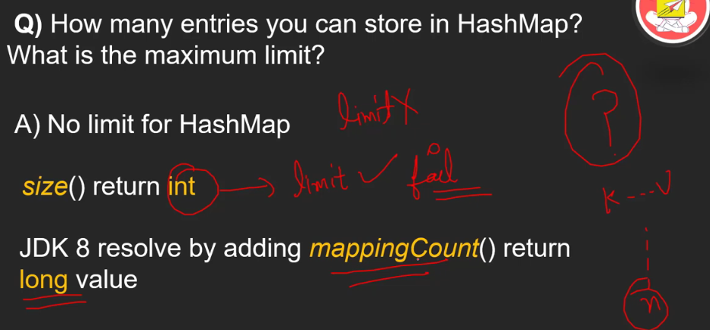

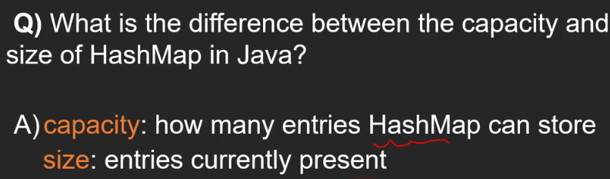

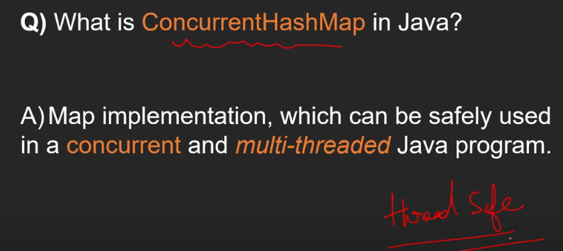

HashTable, Collections.synchrinizedMap(normal_map) and ConcurrentHashMap are both implementation on Map and are thread safe

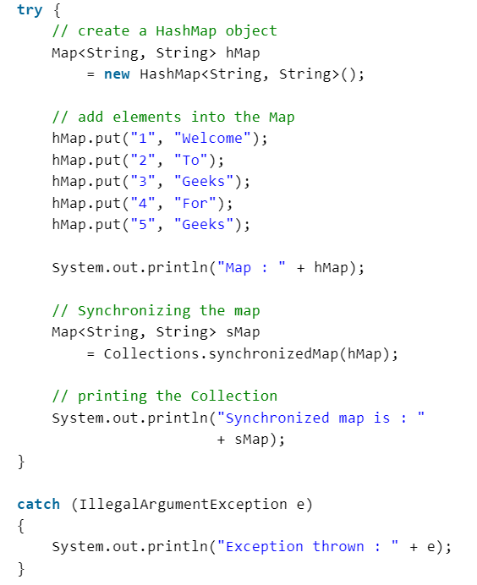

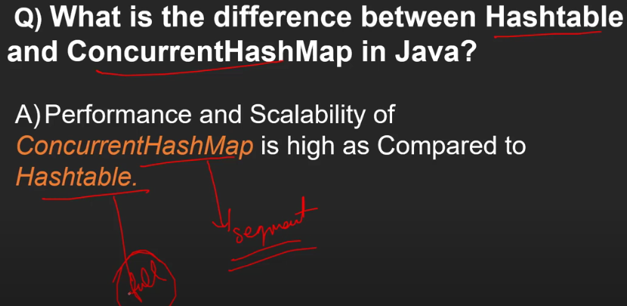

ConcurrentHashMap kuch segments ko lock karta where as Hashtable pure Object ko lock kar deta hai

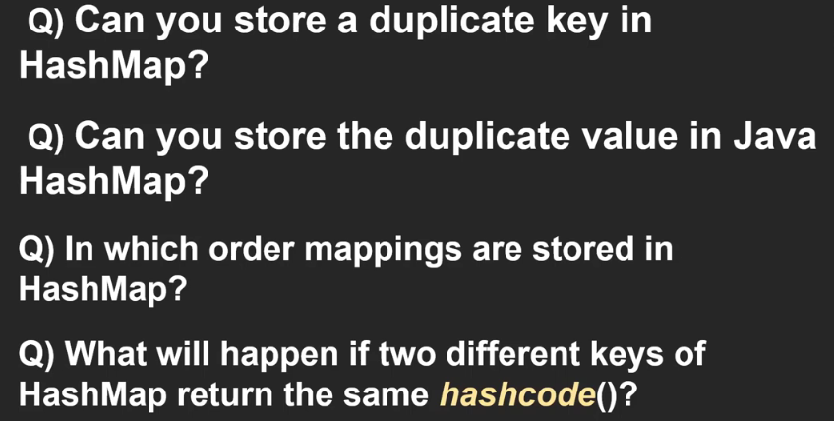

1. No
2. Yes
3. No order
4. Collison (chaining used with ll)



**Serialization** and **Deserialization**: (Asked in IO)

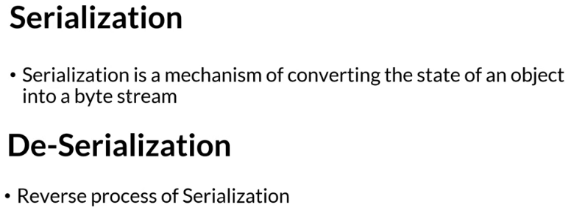

Object State meaning: Us object ke pass active properties hogi, attributes and behavior hogi

After doing Serialization we can transfer object state to **Network**, can store in **Database**, can save in **File**

Again by doing Deserialization we can access the state object received from network, fetched from database or retrieved from file.

When we have a object we cannot transfer it through network. First we have convert it to Byte stream by doing Serialization.

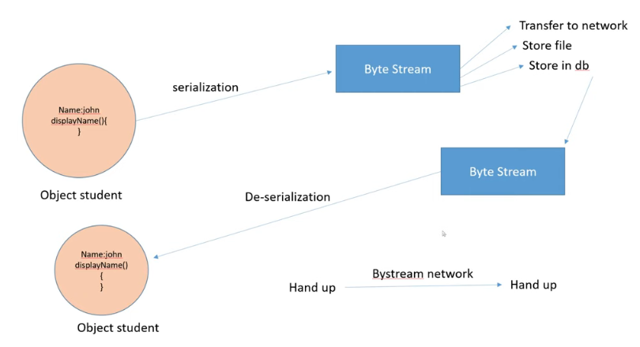

Same state ko transfer kar sakte hai and receiving system us same state ko access kar sakta hai

**Serializable** is a markup interface that tells if a class object is serializable or not.



**Transient** is a keyword which prevents a variable from serializable

Serialization

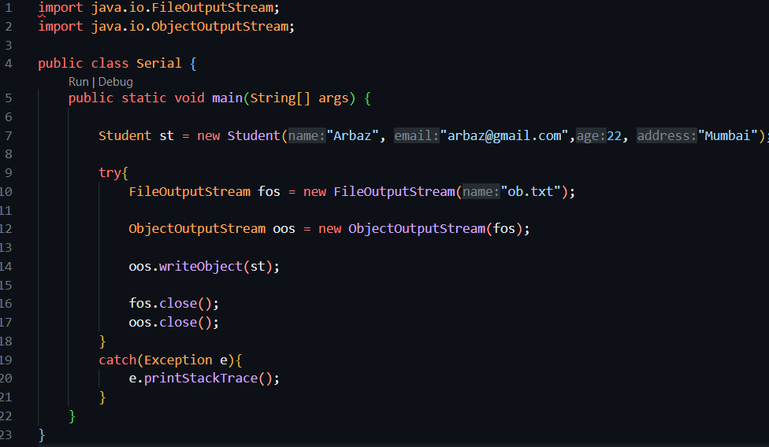

Deserialization

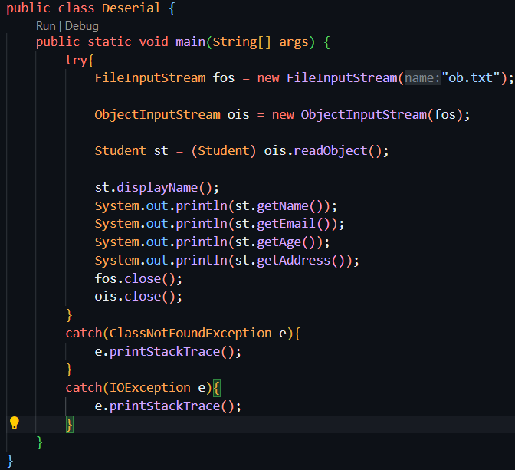

Important class for Serialization

FileOutputStream and ObjectOutputStream

Method: writeObject(obj)

Important class for Deserialization

FileInputStream and ObjectInputStream

Method: readObject()

**Multi -Threading**

**(**Java is Multi-Threading Programming Language**)**

Multi threading is used to achieve Multi tasking

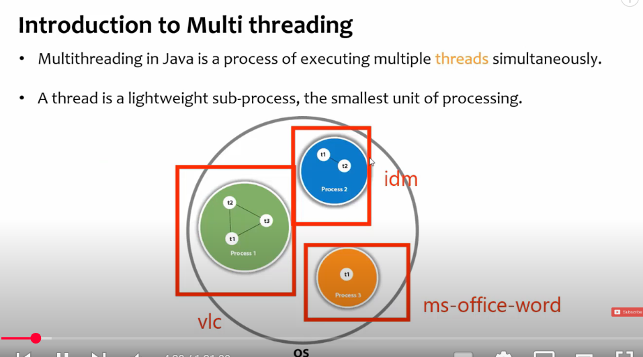

Multi threads forms a process.

IDM – Internet Download Manager

Multi Processing occurs at OS level when Multiple processes runs.

Multi Threading occurs within a single process. The application is developed using a language that supports multi threading. So Multi threading is programming level phenomenon occurs within a single process .

For a Process there needs to be at least one thread.

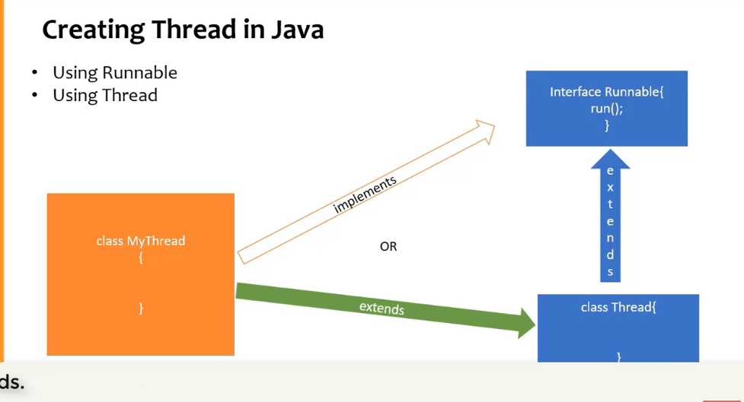

Both are in java.lang package so no need to explicitly import anything.

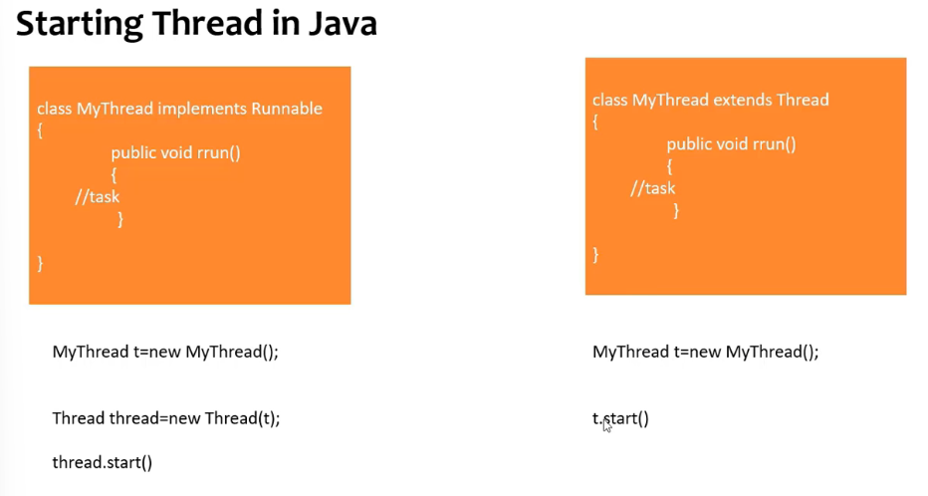

**Best** way is to use **Runnable** interface as we are implementing, we can also extend some other class. If we go with extending Thread class then no other class can be inherited.

**Main**() method is also a thread (main thread), jvm runs main thread and and then it calls other threads.

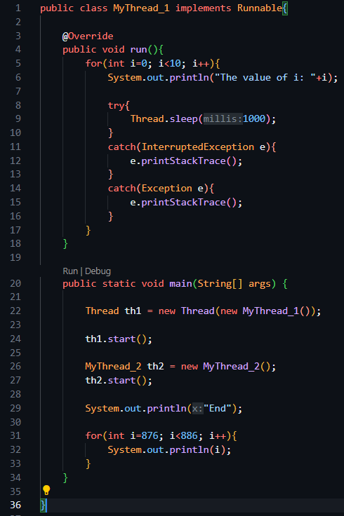

Pehle main thread execute hoga also main thread ka jo bhi statement hai other thread ke alwa wo bhi pehle execite hoga, phir threads execute honge

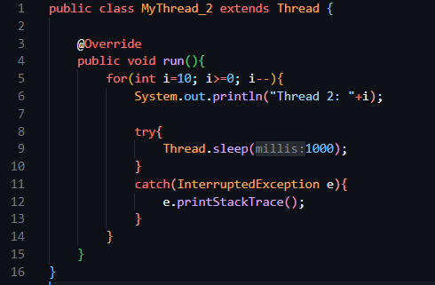

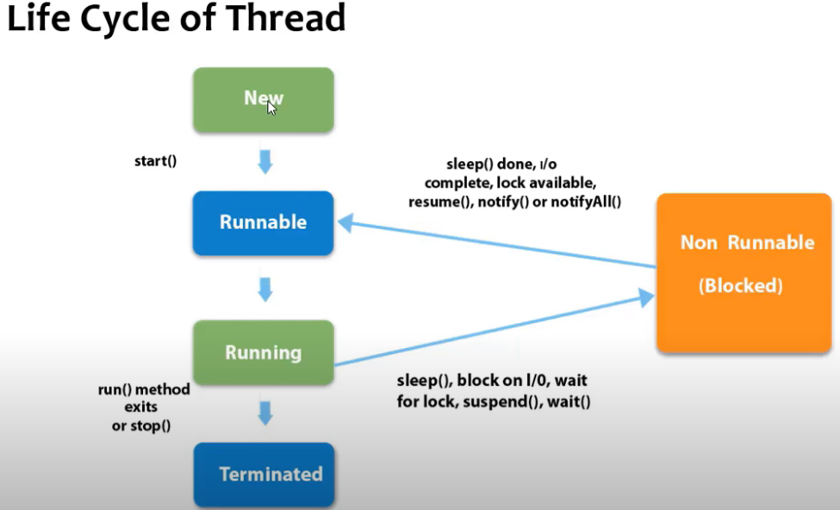

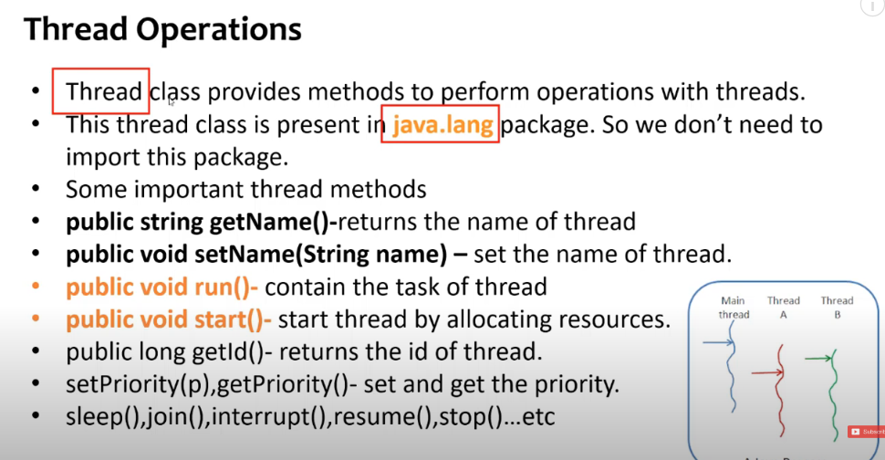

Thread Methods

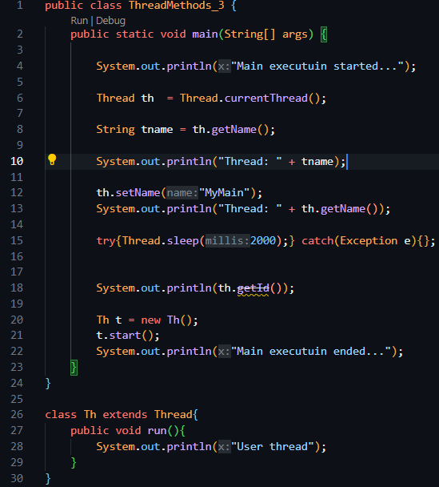

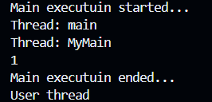

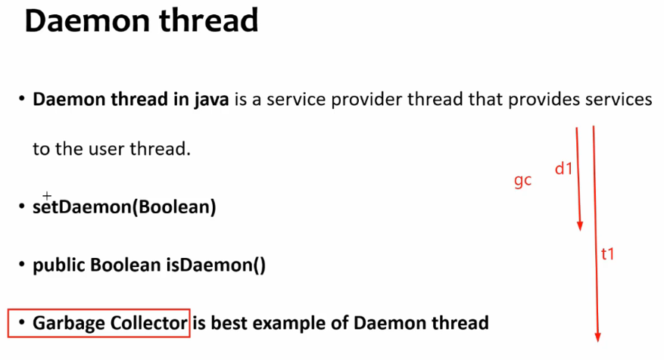

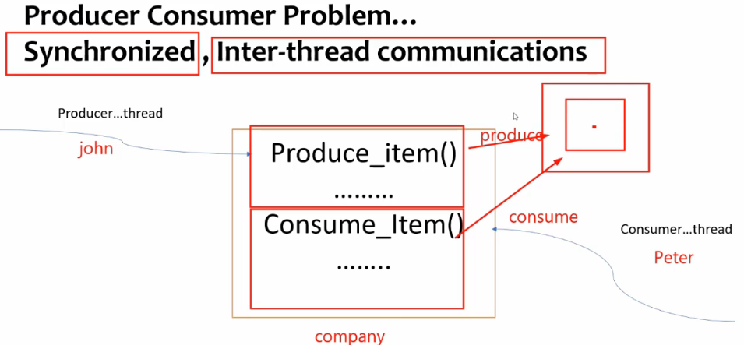

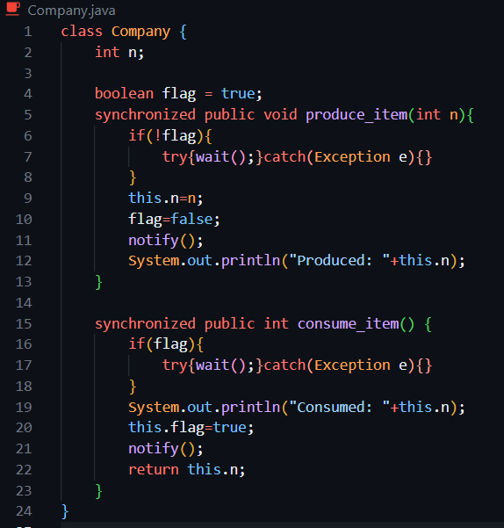

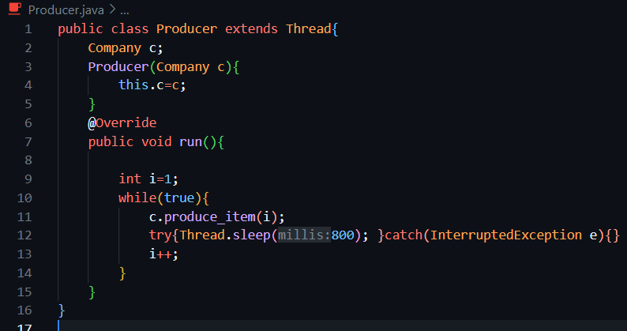

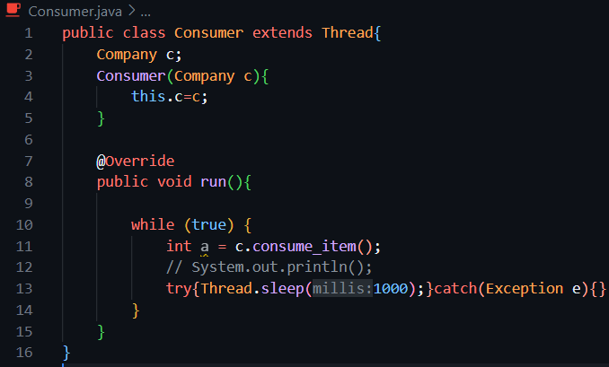

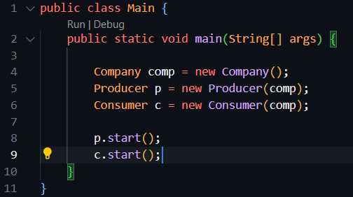

**Number Class (Abstract Class)**

**Number class in Java** is an abstract class that is the superclass of Byte, Short, Integer, Long, Float, and Double classes.

The Byte, Short, Integer, Long, Float, and Double classes are the most commonly used wrapper classes that represent numeric values.

All the numeric type wrappers inherit from abstract class Number. Java Number class and its subclasses are present in java.lang package. It was added in Java 1.0 version.

**Number Class Declaration**

The abstract Number class extends Object class and implements Serializable interface. The general declaration of Number class is as follows:

public abstract class Number

extends Object

implements Serializable

The classes such as AtomicInteger, AtomicLong, BigDecimal, BigInteger, DoubleAccumulator, DoubleAdder, LongAccumulator, and LongAdder also implement Number class.

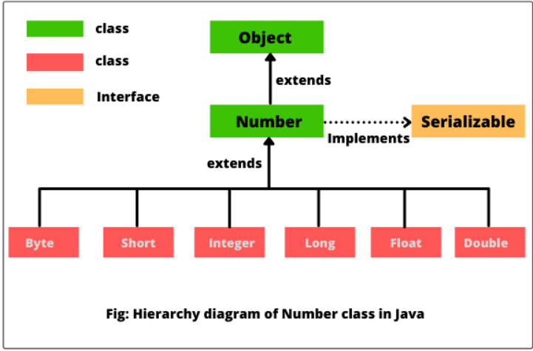

**Methods of Number Class in Java**

Number class defines some useful methods that return the value of an object in each of the different number formats. These methods are as follows:

**1. byte byteValue():** This method returns the value of an object as a byte which may involve rounding or truncation. In other words, it converts the calling object into byte value. The calling object may be an object of Byte, Short, Integer, Long, Float, or Double class.

**2. short shortValue():** This method returns the value of an object as a short which may involve rounding or truncation. In simple words, it converts the calling object into short value.

**3. abstract int intValue():** It returns the value of an object as a short which may involve rounding or truncation. That is, it converts the calling object into int value.

**4. abstract long longValue():** It returns the value of an object as long which may involve rounding or truncation. It is used to convert the calling object into long value.

**5. abstract float floatValue():** This method returns the value of an object as float which may involve rounding.

**6. abstract double doubleValue():** This method returns the value of an object as long which may involve rounding.

**Java lang Classes**:

list of **important classes from java.lang** that are commonly asked in **Java interviews, academic exams, and coding tests**, along with their **key methods and usage**.

**🔹 1. Object**

The root of all Java classes.

**Important methods:**

* equals(Object obj)
* hashCode()
* toString()
* clone()
* finalize() (deprecated)
* getClass()
* wait(), notify(), notifyAll()

➡️ **Used in:** overriding, comparison, synchronization, Object class contracts.

**🔹 2. String (Immutable)**

Handles character sequences.

**Important methods:**

* length()
* charAt(int index)
* substring(int start, int end)
* equals(), equalsIgnoreCase()
* compareTo()
* indexOf(), lastIndexOf()
* toLowerCase(), toUpperCase()
* trim(), replace(), split()
* concat(), valueOf()

➡️ **Used in:** text processing, hashing, string manipulation.

**🔹 3. StringBuilder / StringBuffer**

Mutable character sequences.

**Important methods:**

* append(), insert(), delete()
* reverse()
* toString()
* capacity(), ensureCapacity()

➡️ StringBuilder is faster (not synchronized), StringBuffer is thread-safe.

**🔹 4. Math**

Utility class for mathematical operations.

**Important methods:**

* abs(), max(), min()
* pow(), sqrt()
* ceil(), floor(), round()
* random() (returns a double between 0.0 and 1.0)

➡️ **Used in:** numerical logic, game dev, simulations.

**🔹 5. Integer, Double, etc. (Wrapper Classes)**

Converts between primitives and objects.

**Important methods:**

* parseInt(String) → returns primitive
* valueOf(String) → returns object
* intValue(), doubleValue() (for object to primitive)
* compareTo(), equals()

➡️ **Used in:** collections, autoboxing, parsing.

**🔹 6. System**

Provides access to system-related resources.

**Important methods/fields:**

* System.out.println()
* System.in (for input stream)
* System.err (for error output)
* System.currentTimeMillis(), nanoTime()
* System.gc() (suggest garbage collection)
* exit(int status)

➡️ **Used in:** I/O, performance timing, termination.

**🔹 7. Thread (and Runnable)**

For multithreading.

**Important methods:**

* start(), run()
* sleep(ms), join()
* isAlive(), getName(), setPriority()
* yield(), interrupt()
* setDaemon(true)

➡️ Use Runnable to implement threads without extending class.

**🔹 8. Exception, RuntimeException, Throwable**

Base for error handling.

**Important methods:**

* getMessage()
* printStackTrace()
* getCause()
* initCause()

➡️ Custom exceptions should extend Exception or RuntimeException.

**🔹 9. Class<T>**

Part of reflection API.

**Important methods:**

* forName(String className)
* getDeclaredMethods(), getDeclaredFields()
* newInstance() (deprecated)
* getSuperclass()

➡️ **Used in:** frameworks, ORM, dynamic loading.

**🔹 10. Runtime**

Interacts with the JVM at runtime.

**Important methods:**

* getRuntime()
* exec(String command) → run OS commands
* availableProcessors()
* freeMemory(), totalMemory(), gc()

➡️ **Used in:** resource management, monitoring, running shell commands.

**🔹 11. Enum<E extends Enum<E>>**

Superclass for enums.

**Important methods:**

* values() (returns array of enum constants)
* valueOf(String name)
* ordinal() → index of constant

➡️ Useful for creating type-safe constant sets.

**🔹 12. Number (Abstract class)**

Superclass of wrapper classes.

**Methods to override in subclasses:**

* intValue(), longValue(), floatValue(), doubleValue()

➡️ Used in generic number-based code.

**✅ Bonus: Other Mentionable Classes**

| **Class** | **Key Use** |
| --- | --- |
| Throwable | Superclass of all exceptions and errors |
| Package | Metadata about a package |
| Void | Represents the void return type |

**💡 Common Interview Questions:**

* Difference between String, StringBuilder, StringBuffer
* What is Object.equals() and how to override it properly?
* When to use == vs .equals()?
* What happens if you override hashCode() but not equals()?
* How does Thread.sleep() vs Thread.yield() work?
* How is Integer.valueOf() different from parseInt()?
* Why is String immutable?
* How do you use System.nanoTime() to measure execution time?

**1. Difference between String, StringBuilder, and StringBuffer**

* String: Immutable (cannot be changed).
* StringBuilder: Mutable and **not thread-safe** (faster).
* StringBuffer: Mutable and **thread-safe** (slower).

**2. What is Object.equals() and how to override it properly?**

* equals() checks if two objects are logically equal.
* Override it to compare field values instead of memory addresses.

@Override

public boolean equals(Object obj) {

if (this == obj) return true;

if (!(obj instanceof MyClass)) return false;

MyClass other = (MyClass) obj;

return this.id == other.id;

}

**3. When to use == vs .equals()?**

* == checks reference (memory) equality.
* .equals() checks content/logical equality.

**4. What happens if you override hashCode() but not equals()?**

* May break HashMap, HashSet, etc.
* Always override **both** to maintain consistency.

**5. How does Thread.sleep() vs Thread.yield() work?**

* sleep(ms): Pauses current thread for given milliseconds.
* yield(): Suggests to CPU that current thread can pause to let others run.

**6. How is Integer.valueOf() different from parseInt()?**

* Integer.valueOf() → returns Integer object.
* Integer.parseInt() → returns primitive int.

**7. Why is String immutable?**

* For security, thread safety, and to allow string caching (string pool).

**8. How do you use System.nanoTime() to measure execution time?**

long start = System.nanoTime();

// code to test

long end = System.nanoTime();

System.out.println("Time: " + (end - start) + " ns");

**Abstract Class**

**Abstract Classes vs Interfaces** in Java — including their **need, design, usage, differences, and practical scenarios**, along with **constructor behavior** in abstract classes.

**🔹 1. What is an Abstract Class in Java?**

An abstract class is a class that **cannot be instantiated** and may contain **abstract (unimplemented) methods** as well as **concrete (implemented) methods**.

abstract class Animal {

String name;

Animal(String name) {

this.name = name;

System.out.println("Animal constructor called");

}

abstract void makeSound(); // Abstract method

void sleep() { // Concrete method

System.out.println(name + " is sleeping...");

}

}

**🧪 2. Constructor in Abstract Class**

**✅ Yes, abstract classes can have constructors.**

* The constructor is called **when a subclass is instantiated**.
* It helps to **initialize common fields**.

class Dog extends Animal {

Dog(String name) {

super(name); // Calls constructor of abstract class

}

void makeSound() {

System.out.println(name + " says: Woof!");

}

}

**Output:**

Animal constructor called

Rex says: Woof!

**❓ 3. Why Do We Need Abstract Classes?**

* To provide a **base class** with shared code and common functionality.
* To **enforce a contract** on subclasses (must implement abstract methods).
* To allow **partial implementation** (unlike interfaces before Java 8).
* Good for **“is-a” relationships** (e.g., Dog is-an Animal).

**🔸 4. What is an Interface?**

An interface in Java defines a **contract** that classes must follow. It only contains **method signatures** (no implementation until Java 8).

interface Flyable {

void fly(); // public and abstract by default

}

From **Java 8+**, interfaces can also have:

* default methods (with body)
* static methods
* private methods (from Java 9+)

interface Flyable {

void fly();

default void glide() {

System.out.println("Gliding...");

}

static void checkWings() {

System.out.println("Wings checked.");

}

}

**❓ 5. Why Do We Need Interfaces?**

* To **achieve full abstraction** (before Java 8).
* To implement **multiple inheritance** of types.
* To define **capabilities/behaviors** (e.g., Runnable, Comparable, Serializable).

**🔁 6. Abstract Class vs Interface – Full Comparison**

| **Feature** | **Abstract Class** | **Interface** |
| --- | --- | --- |
| **Instantiation** | Cannot be instantiated | Cannot be instantiated |
| **Methods** | Can have abstract & concrete methods | Only abstract methods (till Java 7); default/static from Java 8 |
| **Constructors** | ✅ Yes | ❌ No |
| **Access Modifiers** | Any (public, protected, private) | Methods are public by default |
| **Variables** | Can have instance variables | Only public static final (constants) |
| **Multiple Inheritance** | ❌ Not supported | ✅ Supported |
| **When to Use** | Shared code + contract | Just the contract (capability) |
| **Extends / Implements** | extends | implements |
| **Default Implementation?** | ✅ Yes | From Java 8+ only |

**🧪 7. Real World Example**

**Using Abstract Class:**

abstract class Shape {

abstract double area();

void describe() {

System.out.println("This is a shape.");

}

}

**Using Interface:**

interface Drawable {

void draw();

}

**Combined:**

class Circle extends Shape implements Drawable {

double radius;

Circle(double r) {

radius = r;

}

double area() {

return Math.PI * radius * radius;

}

public void draw() {

System.out.println("Drawing a circle.");

}

}

**🔧 8. Can a Class Implement Multiple Interfaces?**

✅ Yes, this is allowed and common.

class Car implements Drivable, Flyable, Sailable { ... }

**🚫 9. Can a Class Extend Multiple Abstract Classes?**

❌ No. Java doesn’t support multiple inheritance of classes.

**🔄 10. Can an Interface Extend Another Interface?**

✅ Yes, interfaces can extend multiple other interfaces.

interface A {

void methodA();

}

interface B extends A {

void methodB();

}

**🧠 11. Interview-Focused Points**

| **Question** | **Key Answer** |
| --- | --- |
| Why abstract class if interface exists? | Abstract class allows **partial implementation** and can have constructors/fields |
| Why interface if abstract class exists? | Interfaces enable **multiple inheritance of behavior** |
| Can abstract class have final methods? | ✅ Yes, but cannot be overridden |
| Can interface have fields? | ✅ Only constants (public static final) |
| Can interface methods be private? | ✅ Yes (from Java 9+) but only inside interface |
| Can we have main() in abstract class? | ✅ Yes |
| Can we instantiate abstract class? | ❌ No |
| Can interface extend class? | ❌ No |
| Can abstract class implement interface? | ✅ Yes |

**✅ 12. Best Practices**

* Use **interface** when:
  + You want to define **capabilities** (e.g., Serializable, Cloneable).
  + You need **multiple inheritance** of types.
* Use **abstract class** when:
  + You need **shared state or code**.
  + You want to provide **default behavior and some enforced rules**.

**💬 Summary in One Line:**

Use **interface** for "what an object can do" and **abstract class** for "what an object is".

**Abstract Class (Main Method)**:

Great question!

Yes, an **abstract class in Java can have a main() method**, and it works just like in any normal class — even though **abstract classes cannot be instantiated**, they can still be **used directly to run static methods**, including main().

**✅ Why is this allowed?**

* The main() method is **static**, and **static methods belong to the class**, not to an object.
* You do **not need to create an object** to call a static method.
* Since you **don't need to instantiate** the abstract class, it's perfectly valid to have a main() method in it.

**✅ Example: Abstract Class with main() Method**

abstract class TestAbstract {

public static void main(String[] args) {

System.out.println("Main method in abstract class is running!");

}

}

**🧪 Output:**

Main method in abstract class is running!

**✅ How to run this?**

* Save it as TestAbstract.java
* Compile and run like a normal Java class:

javac TestAbstract.java

java TestAbstract

**📌 Note:**

* You **cannot** do: new TestAbstract() — because it's abstract.
* But you **can run static methods** like main() without instantiating the class.

**🤔 Use Case?**

* Rare in production, but useful for:
  + **Testing** abstract logic.
  + Running **utility methods** inside an abstract class.
  + Providing a **demo** or **runner method**.

**🧠 Summary**

| **Point** | **Explanation** |
| --- | --- |
| Can abstract class have main()? | ✅ Yes |
| Can it run? | ✅ Yes, if it's static |
| Is instantiation needed? | ❌ No |
| Why allowed? | Static methods don’t need objects |

**interfaces** in Java are not like normal (concrete) classes. Here's a **clear comparison** of what **interfaces cannot have**, compared to normal classes and abstract classes.

**✅ Summary Table: What Interfaces Cannot Have (Compared to Classes)**

| **Feature** | **Normal Class** | **Abstract Class** | **Interface** |
| --- | --- | --- | --- |
| Constructors | ✅ Yes | ✅ Yes | ❌ No |
| Instance Variables (non-static) | ✅ Yes | ✅ Yes | ❌ No |
| Instance Initializer Blocks | ✅ Yes | ✅ Yes | ❌ No |
| Object Creation | ✅ Yes | ❌ (can't instantiate) | ❌ No |
| Static Methods | ✅ Yes | ✅ Yes | ✅ Yes (Java 8+) |
| Default Methods | ❌ (only concrete) | ✅ (concrete allowed) | ✅ Yes (Java 8+) |
| Private Methods | ✅ Yes | ✅ Yes | ✅ Yes (Java 9+) |
| Final Methods | ✅ Yes | ✅ Yes | ❌ No |
| Fields with modifiers | Any access/instance | Any access/instance | Only public static final (constants) |
| main() method | ✅ Yes | ✅ Yes | ❌ No (directly not allowed) |
| Static Blocks | ✅ Yes | ✅ Yes | ✅ Yes (Java 8+) |
| Method Bodies | ✅ Yes | ✅ Yes / abstract | Only default/static/private (from Java 8/9) |
| Multiple Inheritance | ❌ No | ❌ No | ✅ Yes (of types only) |

**🚫 Key Things an Interface Cannot Have**

**1. ❌ Constructors**

* Interfaces cannot be instantiated, so **constructors don’t make sense**.

interface Test {

// Error: Constructors not allowed

Test() {}

}

**2. ❌ Instance Variables**

* Interfaces can only have **constants**, i.e., variables that are:
  + public static final

interface MyInterface {

int x = 10; // This is implicitly public static final

}

You cannot have:

int y = 5; // non-static: ❌ not allowed

**3. ❌ Main Method (Usually)**

* Interfaces **can't have main()** like classes, but...
* **You CAN have static main()** from Java 8, but it is rarely used and can't be run directly like in classes.

interface Demo {

static void main(String[] args) {

System.out.println("main() inside interface");

}

}

🛑 You cannot run java Demo from terminal like a class.

**4. ❌ Method Types**

* **No final methods** → Because methods are intended to be overridden.
* **No synchronized methods** → Interfaces only define behavior, no thread logic.

**✅ What Interfaces *Can* Have (Java 8+ and 9+)**

| **Method Type** | **Allowed?** | **Notes** |
| --- | --- | --- |
| Abstract Methods | ✅ Yes | Always allowed |
| Default Methods | ✅ Yes | Java 8+ |
| Static Methods | ✅ Yes | Java 8+ |
| Private Methods | ✅ Yes | Java 9+ only for reuse within default methods |

**📌 Summary in One Line**

Interfaces are for **defining contracts (what a class should do)**, not for holding state or complex logic like classes.

Here’s a **complete example** and explanation of an **abstract class in Java** that:

✅ Has a **constructor**  
✅ Has a **main() method**  
✅ Is used with **inheritance**

**✅ 1. Code Example: Abstract Class with Constructor, Main, and Inheritance**

abstract class Animal {

String name;

// ✅ Constructor

Animal(String name) {

this.name = name;

System.out.println("Animal constructor called");

}

// ✅ Abstract method

abstract void makeSound();

// ✅ Concrete method

void sleep() {

System.out.println(name + " is sleeping...");

}

// ✅ main() method in abstract class

public static void main(String[] args) {

// You cannot create an object of Animal directly

// Animal a = new Animal("Generic"); ❌

// But you can create a subclass object

Dog dog = new Dog("Rex");

dog.makeSound();

dog.sleep();

}

}

// ✅ Subclass that inherits and implements the abstract method

class Dog extends Animal {

Dog(String name) {

super(name); // Calls constructor of abstract class

System.out.println("Dog constructor called");

}

@Override

void makeSound() {

System.out.println(name + " says: Woof!");

}

}

**🧾 2. Output:**

Animal constructor called

Dog constructor called

Rex says: Woof!

Rex is sleeping...

**🔍 3. Breakdown**

**✅ Constructor in Abstract Class**

* It **runs when subclass is created**.
* Used to **initialize shared fields** (name here).

**✅ Inheritance**

* Dog uses extends Animal.
* It must **implement** the abstract method makeSound().

**✅ main() Method**

* Abstract class **can have a static main()**.
* You **cannot create an object** of abstract class in main() directly.
* You can create a **subclass object** to test functionality.

**✅ Key Interview Points**

| **Concept** | **Explanation** |
| --- | --- |
| Can abstract class have constructor? | ✅ Yes, used for initializing shared state |
| Can abstract class have main method? | ✅ Yes, it's static so no object needed |
| Can we create object of abstract class? | ❌ No |
| Can abstract class be inherited? | ✅ Yes |
| Must subclass implement all abstract methods? | ✅ Yes (unless it’s also abstract) |